**Pumpkin Patch & Corn Maze Farm Tours (2025)**

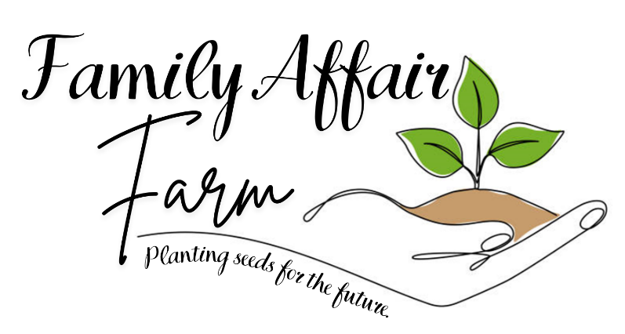 **Time**: 9:45-11:15 or Custom Tours available

**Grades**: K-5

**Cost**: $ 10.00 per student (3% fee for credit card payment)

Come spend the morning & explore the many fun & exciting things happening on the farm during this busy harvest season.

• Farm lesson (Age appropriate) • Corn Maze/Field of Fun

• Drink • Pick a pumpkin

School Name: __________________________School Number_______________________ Contact Person: ________________________Cell Number_________________________

E-mail: __________________________________________________

Tour Dates: September 29,30

October 1, 2, 3, 6, 7, 8, 9, 13, 14, 15, 16, 17, 20, 21, 22, 23, 24, 27,28

**Please list your top 3 date choices**

First Choice__________ Second Choice__________ Third Choice__________

Number of Students ______________________________________________

Number of Teachers/Chaperons ____________________________________

Student Allergies ________________________________________________

**Please email completed form to familyaffairfarm@gmail.com**

**We will email a confirmed date for your tour within 48 hours**

**Thank you for choosing Family Affair Farm for your school tour**

**Family Affair Farm has joined**

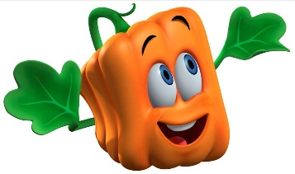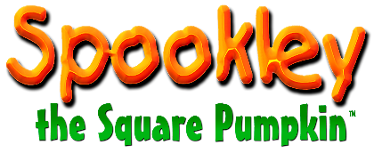

**Spookley the Square Pumpkin in the Bullying Prevention Movement**

October is National Bullying Prevention Month and Family Affair Farm is partnering with Spookley the Square Pumpkin, the Official Spokes-Pumpkin for National Bullying Prevention Month, to raise awareness for bullying prevention. Family Affair Farm will be featuring Spookley the Square Pumpkin in farm-based events to help its younger visitors understand the importance of being tolerant and kind.

Spookley was first introduced to millions of children in the book *The Legend of Spookley the Square Pumpkin*, in which he is shunned by all of the round pumpkins until a mighty storm threatens to destroy the entire pumpkin patch and only Spookley, with his unique shape, can save the day. This fall Spookley is returning as the Official Spokes-Pumpkin for PACER’s National Bullying Prevention Center, which sponsors National Bullying Prevention Month activities at PACER.org/Bullying.  “The culture of bullying won’t end until people across the country take action and show children and teens that they care,” says Julie Hertzog, director of PACER’s National Bullying Prevention Center, which is a division of PACER Center, a national organization.  “We love the way Spookley touches the heart and the mind with his message of tolerance and acceptance.”

Family Affair Farm is one of many family farms across North America that will be embracing Spookley and his story with visitors throughout the fall. Spookley is an adorable character with a wonderful message. Family Affair Farm is delighted to share Spookley with our visitors to raise awareness for National Bullying Prevention Month.

**For more information about Family Affair Farm, please contact Donna Saathoff or Nicole Barth at familyaffairfarm@gmail.com, 410-310-1331 or 717-682-4857, www.familyaffairfarm.wixsite.com/familyaffairfarm, or check us out on Facebook!**